SQL
Session-5
Q1. Create two tables in SQL: influencers (with influencer_id as PRIMARY KEY and name) and posts (with post_id as PRIMARY KEY, influencer_id as FOREIGN KEY, and caption). Insert at least 3 influencers and 2 posts for each influencer.
- Create influencers table
CREATE TABLE influencers (
influencer_id INT PRIMARY KEY,
name VARCHAR(100)
);
INSERT INTO influencers (influencer_id, name)
VALUES
(1, 'Neha Pal'),
(2, 'Sanjna Singh'),
(3, 'Dev Patel');
Output-
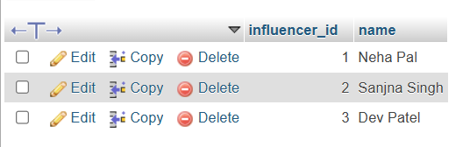

- Create posts table
CREATE TABLE posts (
post_id INT PRIMARY KEY,
influencer_id INT,
caption VARCHAR(100),
FOREIGN KEY (influencer_id) REFERENCES influencers(influencer_id)
);
INSERT INTO posts (post_id, influencer_id, caption)
VALUES
(101, 1, 'My new travel vlog!'),
(102, 1, 'Exploring beautiful places'),
(103, 2, 'Fashion trends 2026'),
(104, 2, 'My daily skincare routine'),
(105, 3, 'Latest technology updates'),
(106, 3, 'Learning SQL and databases');
Output-


Q2.Write an SQL query using INNER JOIN to display each post's caption along with the name of the influencer who posted it, based on the tables you created.
SELECT posts.caption, influencers.name
FROM posts
INNER JOIN influencers
ON posts.influencer_id = influencers.influencer_id;
Output-


Q3. Write an SQL query using LEFT JOIN to show all influencers and their posts, including influencers who haven't posted anything yet. If an influencer has no posts, display 'No Posts' in the caption column.<br><br><em><strong>Hint:</strong> Use IFNULL or COALESCE to handle NULL values in the result.</em>
INSERT INTO influencers (influencer_id, name)
VALUES (4, 'Shreya Mishra');

SELECT influencers.name,
COALESCE(posts.caption, 'No Posts') AS caption FROM influencers
LEFT JOIN posts ON influencers.influencer_id = posts.influencer_id;
Output-

4.Write an SQL query using RIGHT JOIN to list all posts and the corresponding influencer's name, ensuring that even posts without a matching influencer_id (if any) are shown.
SELECT posts.post_id,posts.caption,influencers.name FROM influencers
RIGHT JOIN posts ON influencers.influencer_id = posts.influencer_id;
Output-
